|  |  |  |
| --- | --- | --- |
| Gears of More | | |
| Game Design Document | | |
|  | | |
| One-button mechanical adventure | | |
|  | | |
|  | | |
| A Mechanical Story, Skyfish Studios.  (Aesthetic reference) | | |
| **Capybara** | | |
| Andre Borja Miranda  Eduardo Cavalcante Almeida  Naomi Freire Nagayama  Sebastian Beltran Convers | | |
|  | | |
|  | | |
|  | Table of Contents  Overview 2  Description 2  Goals 2  Pillars 2  Hook 2  3 Cs 2  Character 2  Camera 2  Controls 2  Features 3  Toothed Surfaces 3  3  Smooth Surfaces 3  Spinners (GTH) 4  Bubble-gum 4  Shredders/Moving Enemies (GTH) 5  Production 6  Kanban Board 6  Team Members and Responsibilities 6  Risks and Mitigation 6  Publishing 6  Art 6  Tech 6  Audio 6  UI 7 |  |

# Overview

## Description

A side-scrolling platformer where the player controls a cog within a machine by pressing a single button.

## Goals

What are the design goals of the game? What are you trying to achieve by making this game?

## Pillars

Three pillars that will help inform your design decisions.

1. One Button
2. Satisfying
3. Pillar three

## Hook

What is the unique ‘hook’ to your game?

# 3 Cs

## Character

A little Cog is an essential component of a robot’s heart. It has been torn into pieces by the constant friction and must thus find its missing parts in different corners of the Robot’s body. In its journey, the Cog will encounter spaces that have been consumed by bubble gum. The Cog’s missing parts are the keys to the Robot’s neighboring organs. They will need to find them in each space by **spinning** through them and **jumping** between different surfaces.

## Camera

We will use a side-scrolling camera that automatically follows the Cog.

## Controls

Spinning is the essence of the Cog’s movement. Cog spins automatically. Tapping the button makes it jump. The Cog automatically grips to and traverses any toothed surface that is close enough for them to touch.

# Features

## Toothed Surfaces

Metallic (brass), shiny, geometric.

On Contact: Cog grips these and spins along their shapes. He travels in the same direction unless he collides with a different object or surface.

Tap Button: regular jump.

Hold Button: high jump. The longer it is held the further Cog will travel.

## 

## Smooth Surfaces

Clean, Silver or wood shapes.

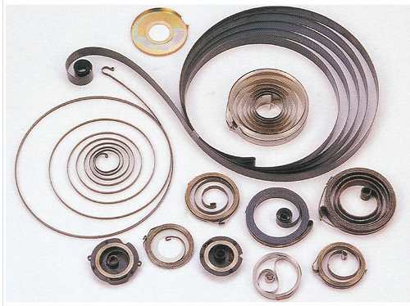On contact: If Cog collides with a flat surface, it bounces off them, reversing directions.

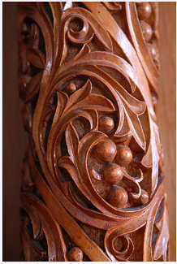

## Spinners (GTH)

A cog-shaped hole or nook that can be used to jump higher than normal.

On contact: Cog fits into it and spins in place.

Tap Button: Cog does a very high jump away from the spinner.

Hold Button: Cog prepares for a very high jump. An arrow indicating the jump trajectory appears and moves back and forth as long as the button is held.

Release Button: Cog jumps very high along the trajectory indicated by the arrow.

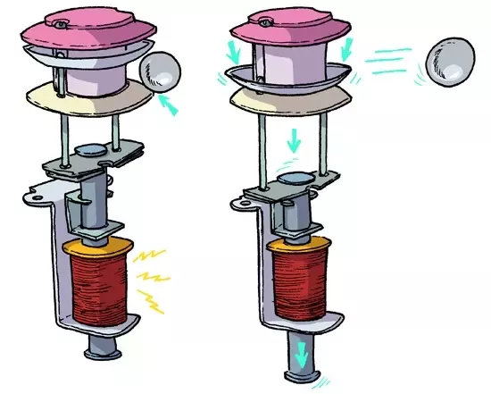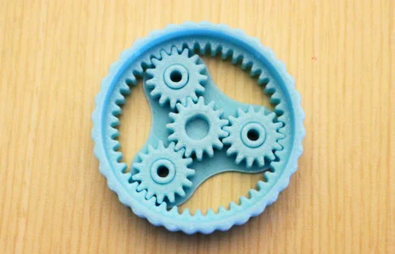

## Bubble-gum

Pieces of pink gunk that are stuck on surfaces and stop Cog’s movement entirely, “killing” him. They are stationary and should be avoided.



## Shredders/Moving Enemies (GTH)

Mean-looking, sharp gears that destroy Cog on contact. They can be stationary or move around toothed surfaces.

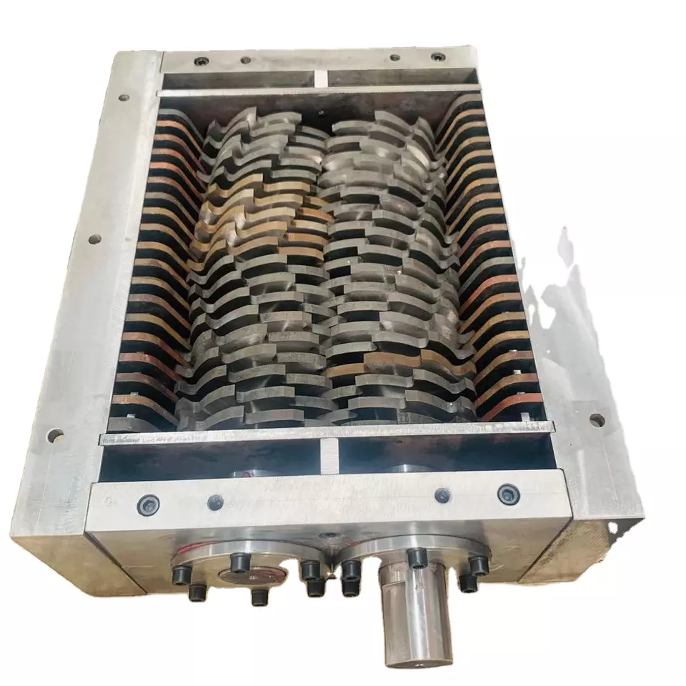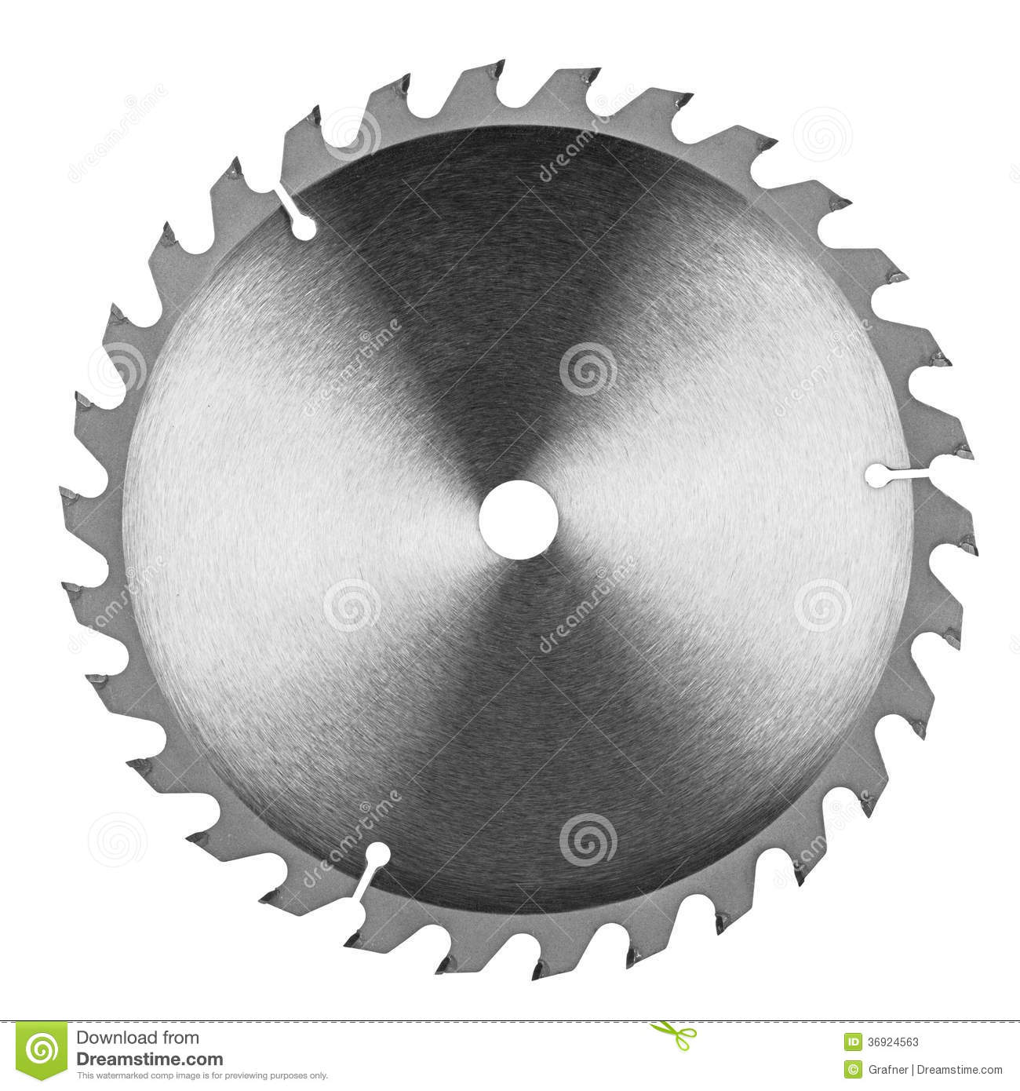

# Production

## Kanban Board

Link to the board.

## Team Members and Responsibilities

|  |  |
| --- | --- |
| Team Member | Main Responsibilities |
| Andre Borja Miranda | Programming |
| Eduardo Cavalcante Almeida | Level Design |
| Naomi Freire Nagayama | Project Management, Art |
| Sebastian Beltran | Game Design, Art |

## Risks and Mitigation

Identify any risks and their possible mitigations. Add more rows as needed. Check example below.

|  |  |
| --- | --- |
| Risk | Mitigation(s) |
| Team has never made a game in two weeks | Prioritize procedural content generation tasks, find online learning resources |
| Team has never made a one-button game |  |

## Publishing

A link to the itch.io game page.

# Art

Inspired mainly by moving pieces like those seen in watches, clocks and other machinery.

Steampunk aesthetics, like brass-colored gears and wood carvings are also a source of visual inspiration for the project.

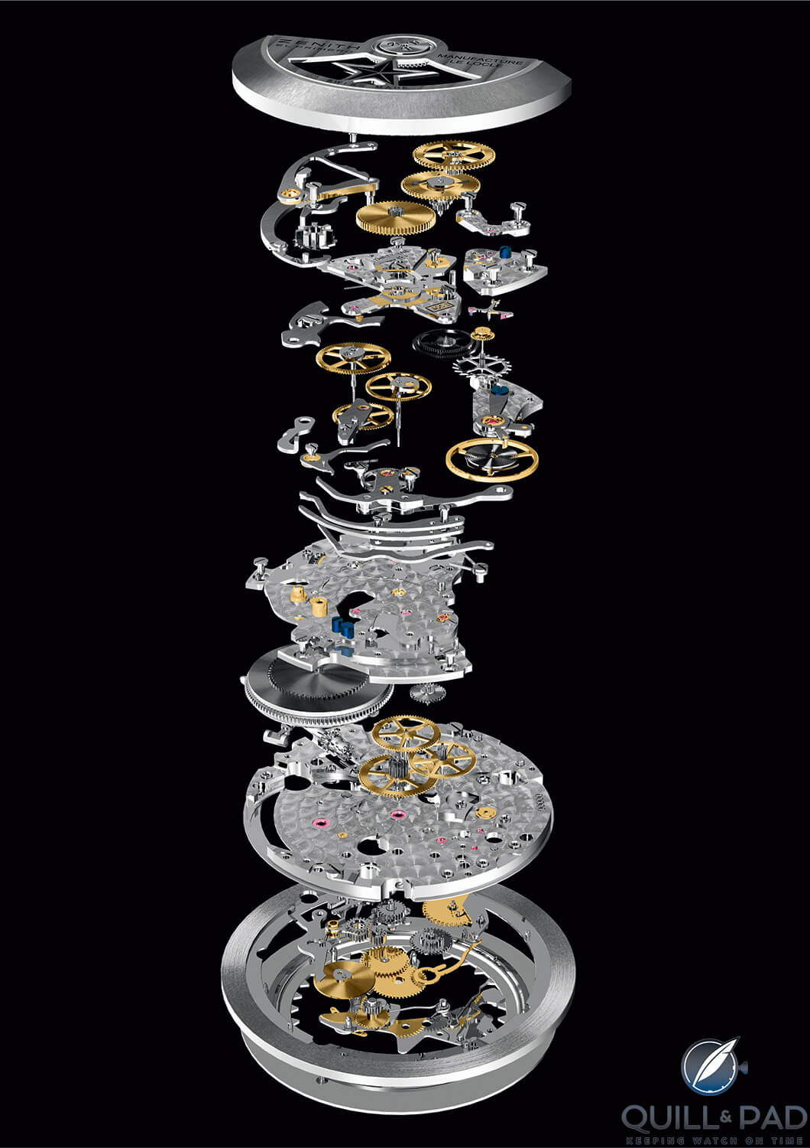

# 

# Tech

We are using the Unity game engine for the game.

Are you using any plug-ins or packages?

Are there any technical considerations, requirements, or constraints?

# Audio

SATISFYING

What is the game’s audio direction?

Are there any audio considerations, requirements, or constraints?

# UI

There is no need to display lives, score or time, so the UI can be effectively neglected during gameplay.

On the Main and Pause menus, UI should be minimal and straightforward.

What style will the UI be?

What UI elements will be needed in the game?

What information must be relayed to the player?